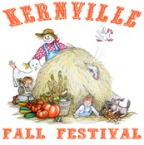
OCTOBER 28-29, 2023
VENDOR APPLICATION
Name _____________________________________ Email ____________________________________
(Please print clearly)
Mailing Address ______________________________________________________________________
Contact Person Phone Number ______________________ Seller's Permit #:______________________
Health Permit FA#: ___________________ (Required for food vendors by Kern County Health Department)

Complete Menu List:___________________________________________________________
TYPE: | FEE: | TOTAL:
Merchandise Vendor | $100.00 (per space)
Food Vendor (Non-Profit) | $150.00 (per space)
Food Vendor (Commercial) | $200.00 (per space)
Electricity | $50.00
Refundable Cleaning Deposit | $100.00 | $100
Insurance Penalty  (Does not Apply to Food Vendors) | $50.00 (per space)
 | TOTAL:
COMPLETED APPLICATION MUST INCLUDE THE FOLLOWING:
- Insurance Certificate (see #1 Vendor Guidelines for insurance requirements)
- Environmental Health Permit (Food Vendors Only)
- Complete menu
- Seller’s Permit● Payment
PLEASE READ THE VENDOR AGREEMENT ON REVERSE. SIGN AND RETURN THE APPLICATION.
**If accepted (see guidelines) we will inform you of your space location.

Mail Payments To:
KERNVILLE CHAMBER OF COMMERCE
PO BOX 397
KERNVILLE, CA 93238—0397
Phone: 760-376-2629 Fax: 760-376-4371 Email: info@gotokernville.com www.gotokernville.com
For Office Use Only:
Space #__________________________ Total Received:
Date Received:
Insurance Cert: or, extra fee: Electricity pd: 410-D Form: Agreement signed:

VENDOR GUIDELINES
There will be no refunds so long as one road is open to the Kern River Valley
1. Payment in full must accompany your application along with your Certificate of Insurance stating: The

" Kernville Chamber of Commerce, its Officers, Directors. Employees. and Agents are Additional Insured
". Liability must be a minimum of $1 Million. For other than food vendors, any vendor without a Certificate of Insurance your FEE will be increased by $50.00 per space. Remember electricity is $50.00, if available. Your space will not be confirmed until all monies are received, and insurance requirements are in order, NO
EXCEPTIONS.
- Your booth payment must be received before the festival with your completed application, all required documents and insurance requirements.
- Please list all items you will be selling. If you bring any items not listed or in poor quality, you may be asked to remove them. All items for sale are subject to approval before the event. All booths will be closely monitored for quality.
- Flags or banners that will obstruct the view of the other spaces may not be put up, NO EXCEPTIONS.
- Vendors should be set up by 9:00 am on Saturday and Spaces should be occupied and remain open Saturday-Sunday. 10AM-8PM on Saturday, 9AM-3PM on Sunday.
- No electric heaters are permitted.
- No double parking will be allowed. We have been advised by the Highway Patrol that traffic citations will be issued.
- Although roving security will be present Saturday evening, each vendor is solely responsible for his own booth, products and personal effects.
- Please keep your area clear of trash, debris, etc. Trash receptacles will be available near the sites. But vendors may NOT deposit cooking grease or oils in trash cans or dumpsters - Yuck! Thank you! When depositing large boxes, please make sure they have been flattened and DO NOT leave them at your site when you leave.
- Fall or Halloween wear is strongly encouraged as the proper attire for our festival. Many townspeople will be decked out in period garb, so "costume up", Pardner!
- We love dogs but do not encourage them. If you bring a dog along, you are solely responsible for it, and it must be leashed or animal control may collect it.
- Your deposit may be forfeited for, among other reasons, space sprawling, unauthorized use of electricity or other services, or not adequately cleaning up your space.

Signature: __________________________________ Date:____________________
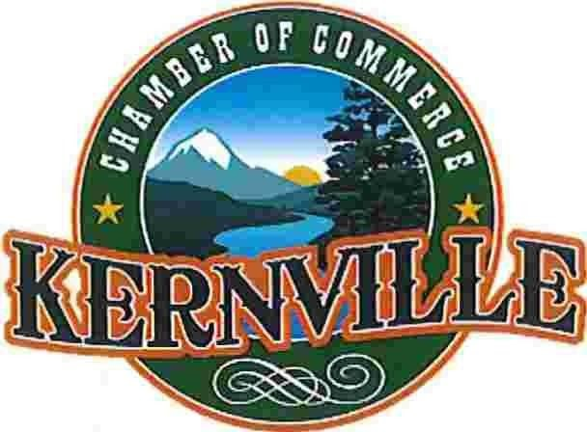
VENDOR INDEMNITY AGREEMENT: As the undersigned
vendor applicant , I agree, on behalf of myself (and my heirs, devisees, representatives and assigns) to indemnity, defend and hold harmless the Kernville Chamber of Commerce, its officers, boards, employees, volunteers and agents (to the fullest extent authorized by law) from all losses, damages, injuries, death, claims, suits and expenses, including attorney's fees, of any type or nature arising out of or relating to my/our presence on (or access to) and participation at properties where the event is held. I further understand that liability insurance protection is solely my responsibility and none is provided by the Chamber's insurance policy.
I have read all of the above (in addition to the Vendor Guidelines) and agree.
____________________________ _____________________________
Print Name *Signature and Title
Date: _________________
*Signatures Required:
Sole proprietorship – sign as owner
Corporation – officer
Limited Liability Company – Managing Partner
Partnership – General Partner

